|  |  |
| --- | --- |
|  | Foundation Activity 6 Introduction to Soldering |

Contents and Learning Outcomes

Students will,

1. Learn to make wire-wire solder joints
2. Solder together a voltage testing LED circuit

This activity should take **~1 hour (1.5 hours recommended)** to complete:

[Materials and Costs per Student 1](#_Toc531543688)

[Lesson 3](#_Toc531543689)

[Activity Overview (2 minutes) 3](#_Toc531543690)

[What is Soldering? (2 Minutes) 3](#_Toc531543691)

[Soldering Tools and Safety (10 Minutes) 3](#_Toc531543692)

[Our Objective: Voltage Tester Circuit (5 Minutes) 4](#_Toc531543693)

[How to make a Wire-to-Wire Solder Joint (10 minutes) 5](#_Toc531543694)

[Soldering Demonstration (5 Minutes) 7](#_Toc531543695)

[Solder and Test the circuit (20 minutes) 7](#_Toc531543696)

[Debrief Discussion (5 minutes) 7](#_Toc531543697)

[Challenge and Explore 8](#_Toc531543698)

[Try Desoldering a Joint 8](#_Toc531543699)

[Try Through-Hole Soldering 8](#_Toc531543700)

[Try Extra-Strong Wire Wrapping 10](#_Toc531543701)

[Try Making a Straight Wire-to-Wire Solder Joint 10](#_Toc531543702)

[Frequently Asked Questions 11](#_Toc531543703)

Materials and Costs per Student

All of the materials listed here were purchased in Kathmandu in a neighborhood called Ason, just south of the popular tourist area named Thamel, with the exception of the safety glasses which were purchased in the Teku neighborhood. If purchasing equivalent parts directly from China through a website like AliExpress, the parts will likely cost twice as much. If purchasing from western vendors such as Amazon, the parts will likely cost three times as much.

|  |  |  |  |  |  |
| --- | --- | --- | --- | --- | --- |
| Cost of Setting Up 10 Soldering Stations | | | | | |
| Item | **Unit Cost.** | **Qty** | **Cost for 10 Stations1** | **Expendable2** | **Expendable Cost\*** |
| Solder tip sponge | 0.13 | 10 | 1.28 | y | 1.28 |
| Soldering iron 40W | 3.21 | 10 | 32.05 |  | 0.00 |
| Soldering iron stand | 1.47 | 10 | 14.74 |  | 0.00 |
| Solder | 0.96 | 10 | 9.62 | y | 9.62 |
| Extra soldering tip | 0.71 | 10 | 7.05 | y | 7.05 |
| Solder flux | 0.38 | 5 | 1.92 | y | 1.92 |
| Solder pump | 1.28 | 5 | 6.41 |  | 0.00 |
| 3-plug extension cord with switches | 2.56 | 4 | 10.26 |  | 0.00 |
| Flush cutters | 1.54 | 5 | 7.69 |  | 0.00 |
| Wire strippers (variable) | 0.96 | 5 | 4.81 |  | 0.00 |
| Safety glasses | 0.77 | 20 | 15.38 |  | 0.00 |
| ****Total Cost for 10 Stations**** |  |  | **$111.22 CAD** |  | **$19.87 CAD** |
| ****Material Costs Per Student**** | | | | | |
| Item | **Unit Cost.** | **Qty** | **Cost per Student** | **Expendable**[**2**](#fn:2) | **Expendable Cost** |
| LED, white, 5mm | **0.02** | **1** | **0.02** | **Y** | **0.02** |
| Resistor, 1/4W, 4.7 kohm | **0.01** | **1** | **0.01** | **Y** | **0.01** |
| Wire, Stranded, 22 AWG, 10cm | **0.07** | **1** | **0.07** | **Y** | **0.07** |
| ****Total Cost per Student**** |  |  | **$ 0.10 CAD** |  | **$ 0.10 CAD** |

1. *Currency is CAD, 2017-06-10. Assuming one set of parts per student.*
2. *Likely to be broken or lost during the activity.*

*\*Depending on use, I expect the Expendable Cost to be the yearly up-keep cost for the 10 soldering stations*

Each student should also get one printed copy of the activity handout. Having tape or hot-glue is also recommended for the students to insulate their completed circuits. Have an assortment of batteries (one less than 3V, one greater than 3V) with the polarity hidden for the students to test their circuits on.

Lesson

Before starting the activity, check that the soldering irons are heating up as expected and doing basic maintenance if necessary to ensure the tips are in good condition (well tinned, see §How to make a Wire-to-Wire Solder Joint). Ensure that the surface used for the soldering part of the activity is heat-resistant.

**Bold text** indicates directions or notes specifically for the instructor.

Activity Overview (2 minutes)

In the last activity we programmed an Arduino to make an RGB LED blink between different colours. We learned about how programs run from top to bottom, then loop back to the top. We also learned about functions like DigitalWrite, and their arguments (pin, state).

Today, we’re going to:

1. Learn what soldering is, why it’s useful, and how to do it.
2. Try soldering.
3. Solder together a voltage testing tool built from a resistor and an LED.

What is Soldering? (2 Minutes)

**Introduce students to the concept of soldering according to the following key points.**

* Soldering is the use of molten metal to make permanent electrical connections.
* Why solder? What’s wrong with just using a breadboard like we have so far in the activities? It allows us to make more permanent and reliable circuits that are smaller. Parts easily come out of breadboards, and are limited to connections on the rows and columns of the breadboard
* There are many different kinds of solder-joints, but today we’re going to focus on wire-to-wire soldering

Soldering Tools and Safety (10 Minutes)

**Show an example of, and explain each of the following tools:**

|  |  |  |
| --- | --- | --- |
| [[1]](#footnote-1) | Solder | A soft metal that melts at a low temperature (usually a combination of lead and tin) |
|  | Soldering Iron | Used to melt the solder and heat the parts to be soldered |
| C:\Users\Harryp\MEGA\Surface Pro 2\Nepal\Himalayan Makers Guild\Activities\Activity 8 - Intro to Soldering\images\icons\png\flux.png | Flux | A paste/liquid that, when heated, helps the solder flow and bond to other metals |
| C:\Users\Harryp\MEGA\Surface Pro 2\Nepal\Himalayan Makers Guild\Activities\Activity 8 - Intro to Soldering\images\icons\png\sponge.png | Soldering Sponge | For cleaning the tip of the iron |

**Sketch on the board and explain each of the following safety items:**

1. Always wear safety glasses. Hot solder or clipped wires can easily fly off a part you are working on. Even if you are not the one soldering, if you’re at the soldering station you need to have safety glasses on!
2. Solder fumes can be harmful, so always work in a well-ventilated area, preferably with a fume extractor fan.
3. Be careful of the hot soldering iron. Do not do anything but solder while holding the soldering iron. As soon as you’re done making the joint, return the iron to the stand.
4. Solder often contains lead, which is a dangerous heavy metal. Once it enters your body, it never comes out, and if you accumulate too much it can cause memory damage or infertility. Never touch your face when soldering. Always wash your hands immediately after soldering.

|  |  |  |
| --- | --- | --- |
|  | Wear safety glasses. |  |
| C:\Users\Harryp\MEGA\Surface Pro 2\Nepal\Himalayan Makers Guild\Activities\Activity 8 - Intro to Soldering\images\icons\png\wind.png | Work in a well-ventilated area. |  |
| C:\Users\Harryp\MEGA\Surface Pro 2\Nepal\Himalayan Makers Guild\Activities\Activity 8 - Intro to Soldering\images\icons\png\flame.png | Only hold the soldering iron while soldering. Otherwise, put it in the soldering iron stand. |  |
| C:\Users\Harryp\MEGA\Surface Pro 2\Nepal\Himalayan Makers Guild\Activities\Activity 8 - Intro to Soldering\images\icons\png\003-hands.png | Wash your hands after soldering and do not touch your face while working with solder. |  |

Our Objective: Voltage Tester Circuit (5 Minutes)

We are going to solder a circuit that will allow us to check for small DC voltages (not voltages from the wall!). By connecting the (+) and (–) sides of the tester to a circuit, we can test to see if a voltage of +3V or greater is present (up to 9V is okay with this circuit). It is the same as our usual LED light circuit, but with more resistance to protect the LED from higher voltages.

|  |  |
| --- | --- |
| If the voltage across the terminals is greater than 3V, the LED will turn ON. | C:\Users\Harryp\MEGA\Surface Pro 2\Nepal\Himalayan Makers Guild\Activities\Foundation Activities\FA6 - Intro to Soldering\images\Eagle\voltage_tester_on.png |
| Otherwise, the LED will be OFF**.** | C:\Users\Harryp\MEGA\Surface Pro 2\Nepal\Himalayan Makers Guild\Activities\Foundation Activities\FA6 - Intro to Soldering\images\Eagle\voltage_tester_off.png |

This is helpful for finding which connections are positive or negative, or to make sure that we are getting a voltage in our circuit. However, this circuit should not be used for voltages over 9V to make sure the LED and resistor don’t get damaged.

**Note that repeated reverse biasing of the circuit at 9V can still damage the LED, so some students’ circuits may stop working if used often to test 9V polarities.**

How to make a Wire-to-Wire Solder Joint (10 minutes)

**Instruct students on how to make a wire-to-wire solder joint according to the following points.**

**Note that for some students, especially younger ones, all of the details below may not be necessary. The student handout represents a good minimum of information that the students should have before trying soldering.**

Three points to keep in mind:

1. Solder moves from cold to hot surfaces, so it is important to heat BOTH the wires we’re joining at the same time.
2. Solder moves most easily on “wetted” surfaces that already have some solder on them. Flux improves wetting. The tip of the iron should be shiny, and the solder should move onto the iron as it melts (not ball up on the solder wire).
3. The “sweet spot” of the iron is on the side of the tip, 1-2mm up from the end of the tip. We should use this surface to contact the parts being soldered together

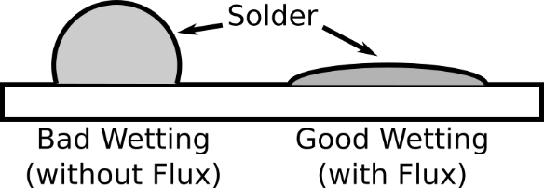

Before you start, make sure both the wires you’re soldering are clean. If they are dirty or show oxidation (rust), clean them with isopropyl alcohol (usually available at a drug store or pharmacy).

1. If the wires are insulated, remove the insulation with wire strippers, then twist the two wires together.
2. Secure them so they hold still while you apply the solder (sometimes you can hold them with your hand, otherwise use a small clamp, tape, or special “helping-hands” designed for soldering).
3. Put a small amount of flux on the wires where they will be soldered together; flux improves the surface wetting, helping the solder flow easily. Note: sometimes solder comes with a flux-core, but adding a bit of flux before soldering is still helpful.

|  |  |
| --- | --- |
| C:\Users\Harryp\MEGA\Surface Pro 2\Nepal\Himalayan Makers Guild\Activities\Foundation Activities\FA6 - Intro to Soldering\images\wire-wire-joint.png | 1. Tin the soldering iron tip by melting solder on it, then wiping the extra solder off onto the sponge. This gives the solder tip good wetting. |
| 1. Touch the side of the soldering iron to the joint so that it contacts both the wires. |
| 1. Apply the solder so that it touches the wires on the side opposite where the iron is touching. |
| 1. Remove the solder wire from the joint. (If you take away the iron first, the solder wire will stick to the joint!) |
| 1. Remove the soldering iron from the joint. |

For step 6, when first applying the solder it may touch the iron tip too, but once a little solder has melted (a “heat bridge”) it should be moved immediately to the side opposite the iron tip so that the solder flows over the wires towards the hot soldering iron tip.

The completed joint should look smooth and shiny.

It is also possible to solder the wires together without twisting them. To do this, tin each wire separately with solder, then position them together and follow steps 4-8 above without adding more solder (exclude step 6); the solder from each tinned wire will flow together, forming the joint.

Soldering Demonstration (5 Minutes)

**Demonstrate making a solder joint between the leg of a resistor and a stranded wire, including how to use the wire-strippers to remove some insulation from the stranded wire.**

Solder and Test the circuit (20 minutes)

**Students will now attempt to make solder joints on their own by making the voltage tester circuit.**

To make the voltage tester, we’ll need to make three solder joints (draw the circuit out on the board):

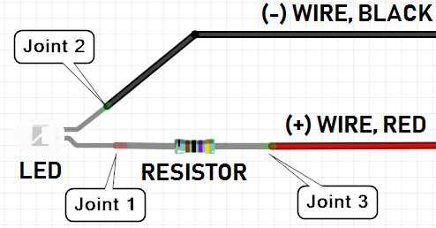[[2]](#footnote-2)

Start by trying a solder joint between two scrap pieces of wire. When you’ve done that, show your joint to the instructor and you’ll be given the parts to make the voltage tester. Be careful with the polarity of the LED! The red wire should go on the long leg (+).

**When the students have completed their circuits, give them some electric tape or hot-glue to protect the exposed metal and prevent short-circuits. Have them test the circuit with a variety of batteries (e.g. it will turn on with a coin-cell lithium battery, or a 9V, but not with a single AA or AAA battery; also, it will only turn on when oriented correctly to the (+) and (-) terminals of the battery).**

Debrief Discussion (5 minutes)

**Encourage a discussion among the students for them to share their thoughts on the activity.**

Today we learned what soldering is, how it can make our circuits smaller and more reliable, and how to solder two wires together. Why is this important? What applications does this have? Some possible answers include:

* We can use soldering to repair broken electronics, from power-cords to computers
* Soldering is used inside most electronic products, so we can better understand how those products are built

What worked? What didn’t work? Why didn’t it work? What could we do next, or how could we make the circuit better?

Challenge and Explore

**If a student completes the lesson early, evaluate their understanding by asking them to try the following:**

Try Desoldering a Joint

To separate two wires, it is good enough to heat up the joint until the solder melts, then pull the two wires apart. However, if you need to get more of the solder off the joint, use a solder sucker or solder wick. While solder wick is like a sponge that helps absorb solder when hot, a solder sucker is like a little vacuum that can be used to suck the molten solder off the joint. To use the solder sucker:

1. Load the solder sucker by depressing the plunger
2. Tin the soldering iron tip
3. Touch the soldering iron to the joint
4. When the solder has melted, keep the soldering iron on the joint and press the tip of the solder sucker against the joint; press the button to activate the solder sucker
5. While the remaining solder is still hot, pull the two wires apart
6. Remove the soldering iron from the joint

Try Through-Hole Soldering

**For more information, see the** [**Adafruit Guide to Excellent Soldering**](https://learn.adafruit.com/adafruit-guide-excellent-soldering?view=all)**[[3]](#footnote-3).**

**Note that for some students, especially younger ones, all of the details below may not be necessary. The 5-step image in the table below represents a good minimum of information that the students should have before trying through-hole soldering.**

Before you start

1. Put the wire through the plated hole and secure the parts. If they move while soldering, the joint will not work. They can be secured using clamps, tape, sticky-tack, or just by holding the parts down with your hands. Bending the legs of the part out after putting it through the holes is a good way to prevent it from moving while soldering.
2. If the parts are dirty, or show oxidation (rust), clean them with isopropyl alcohol (usually available at a drug store or pharmacy).
3. Put a small amount of flux on the surfaces to be soldered; flux improves the surface wetting, helping the solder flow easily. Note: sometimes solder comes with a flux-core, in which case adding flux before soldering is not necessary.



* Three points to keep in mind:
  + Solder moves from cold to hot surfaces
  + Solder moves most easily on “wetted” surfaces, that already have some solder on them. Flux improves wetting. The tip of the iron should be shiny, and the solder should move onto the iron (not ball up on the solder wire).
  + The “sweet spot” of the iron is on the side of the tip, 1-2mm up from the end of the tip. We should use this surface to contact the parts being soldered together

|  |  |
| --- | --- |
|  | Tin the soldering iron tip by melting solder on it, then wiping off the extra solder onto the sponge. This gives the solder tip good wetting. |
| Touch the side of the soldering iron to the joint so that it contacts both the wire and the plated hole. |
| Apply the solder so that it touches the wire and the plated hole on the side opposite where the iron is touching; hold it there until the solder melts and flows to cover the plate and wire. |
| Remove the solder wire from the joint. |
| Remove the soldering iron from the joint. |

A completed solder joint should look like this:

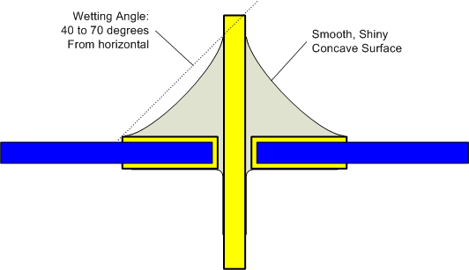[[4]](#footnote-4)

Here are some examples of some common problems:

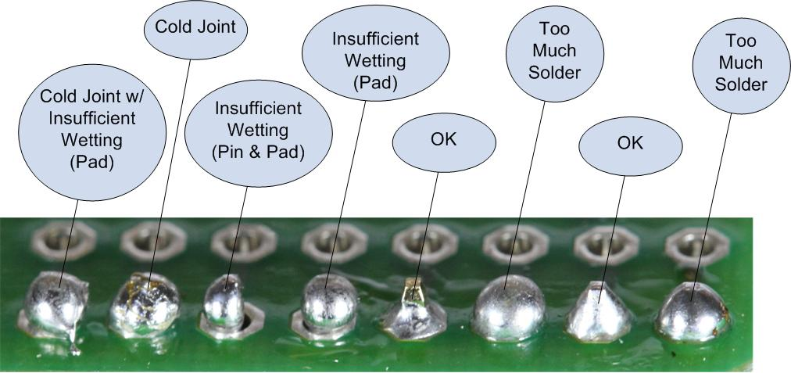[[5]](#footnote-5)

Try Extra-Strong Wire Wrapping

To make an even stronger solder joint, try wrapping each wire around the other, and soldering together both wrap-points:



Try Making a Straight Wire-to-Wire Solder Joint

Tin each wire separately with solder, then position them together and follow steps 4-8 for wire-to-wire soldering without adding more solder (exclude step 6); the solder from each tinned wire will flow together, forming the joint.

Frequently Asked Questions

* My solder isn’t melting on the iron, what’s wrong?
  + Is the iron plugged in and powered on?
  + Is the tip dirty or oxidized? If so, clean it on the sponge and try dipping it in flux before melting the solder on the tip.
  + Make sure you’re contacting the side of the iron, 1-2mm up from the tip rather than directly on the tip.
  + Are you sure that’s solder wire and not normal wire that you’re trying to melt?
* Why isn’t the solder sucker working?
  + Is the plunger depressed?
  + Are you keeping the soldering iron pressed to the joint so that the solder is melted when you try to suck it?
* Why isn’t the solder sticking to the wires?
  + Are you sure you’re touching both wires with the soldering iron?
  + Are the wires clean and did you apply a little bit of flux them?

1. Icons made by Freepik from [*www.flaticon.com*](http://www.flaticon.com), CC-BY-SA-3.0 [↑](#footnote-ref-1)
2. Circuit image made with Fritzing [↑](#footnote-ref-2)
3. https://learn.adafruit.com/adafruit-guide-excellent-soldering?view=all [↑](#footnote-ref-3)
4. by Bill Earl from [Adafruit](https://learn.adafruit.com/assets/2029), CC-BY-SA-3.0 [↑](#footnote-ref-4)
5. by Bill Earl from [Adafruit](https://learn.adafruit.com/assets/1978), CC-BY-SA-3.0 [↑](#footnote-ref-5)